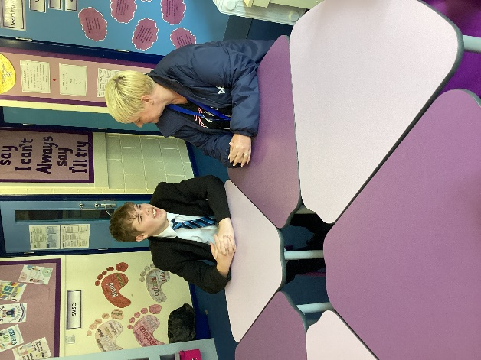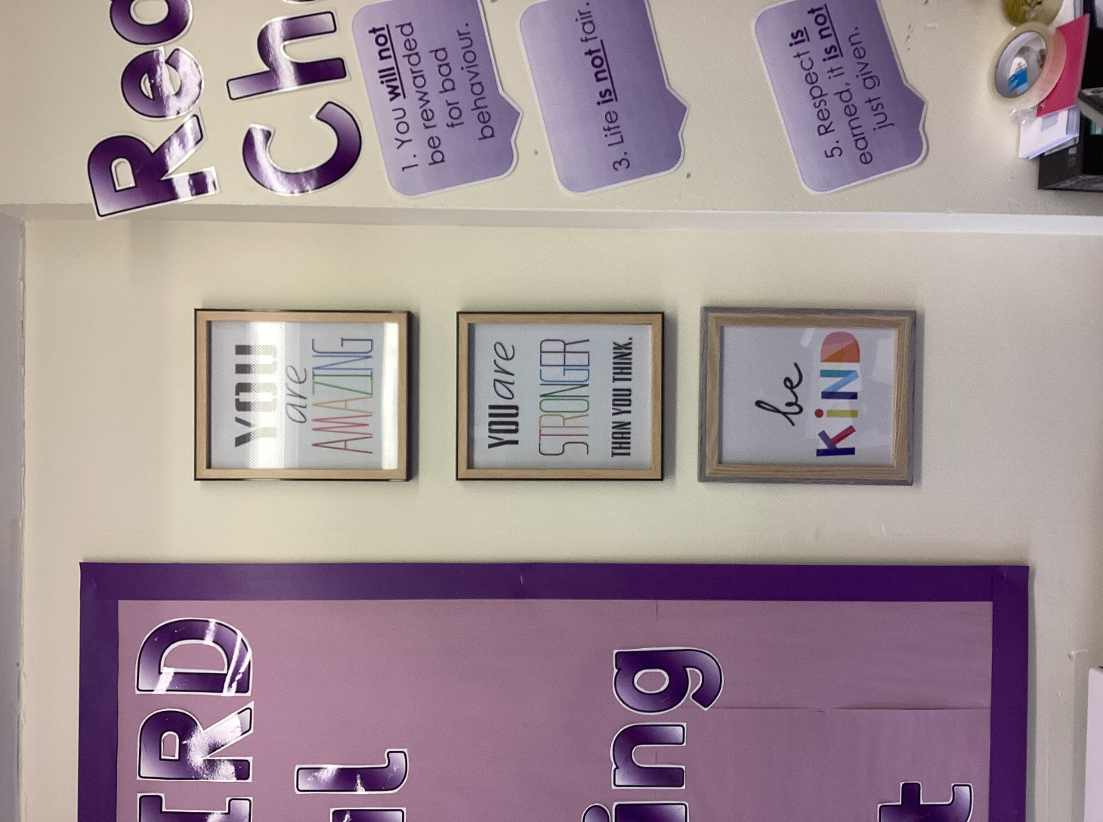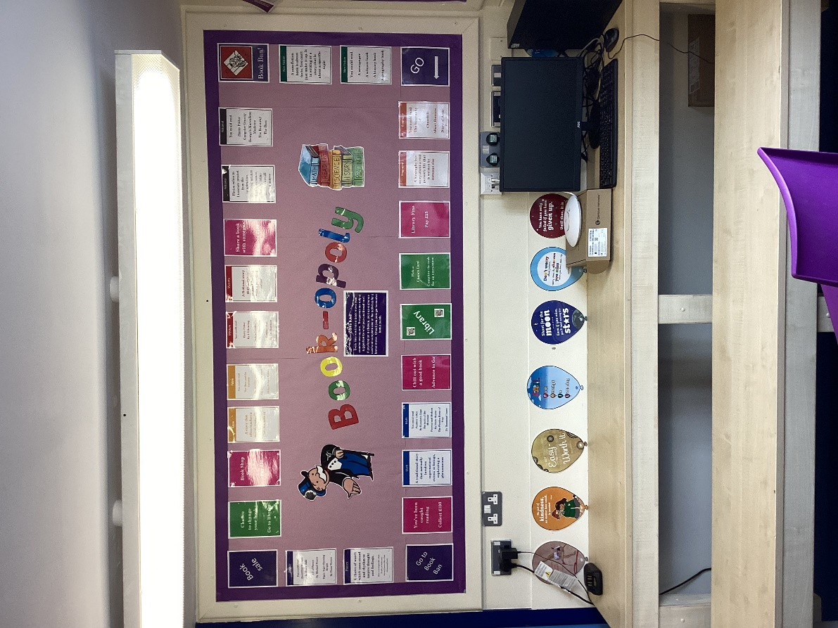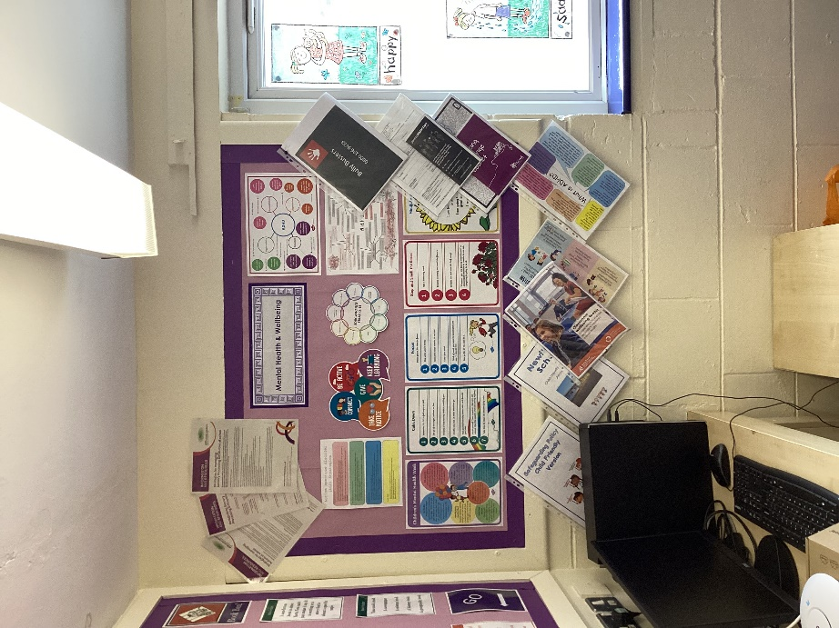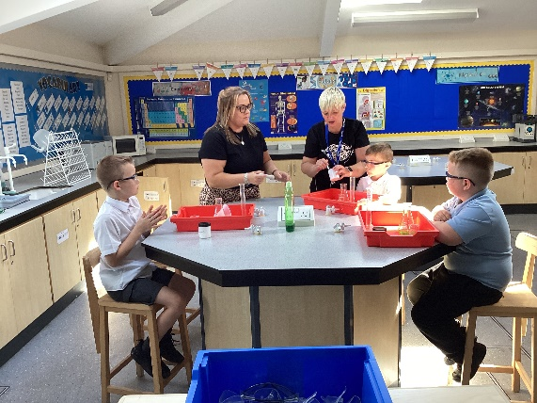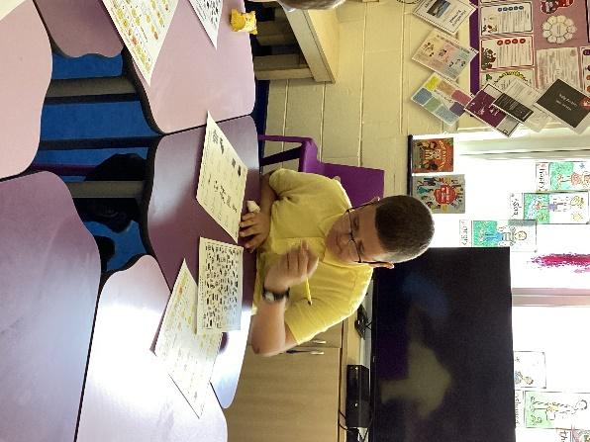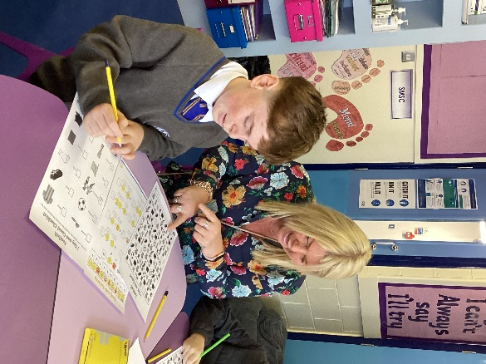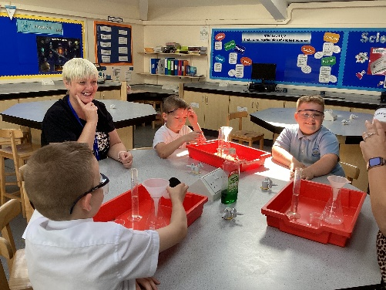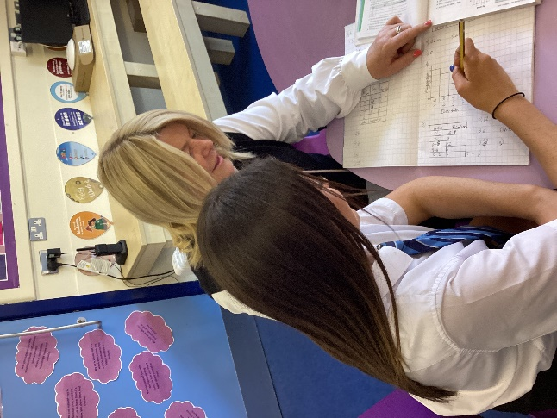

The mentors are willing to listen and help you if you need someone to talk too.

I think the mentors are great to help the school

The Mentors

I use the mentors top calm down they are good at talking to you and supporting you. I also go to them about safety since they are safeguarding

They have been a great help to me while in school, both Miss Robinson and Miss Riley are listeners and help when I have a problem or a concern

I feel the mentors have helped me when I was down and helped me when I was upset, they have been a great help with my school life.

**The Mentors Room**